MUNAZA MUNIR 03220147287 70146760@student.uol.edu.pk
SELINIUM
TEST 01 OF SCENARIO 01 - NAVIGATION TESTING
PASSED SUCCESSFULLY
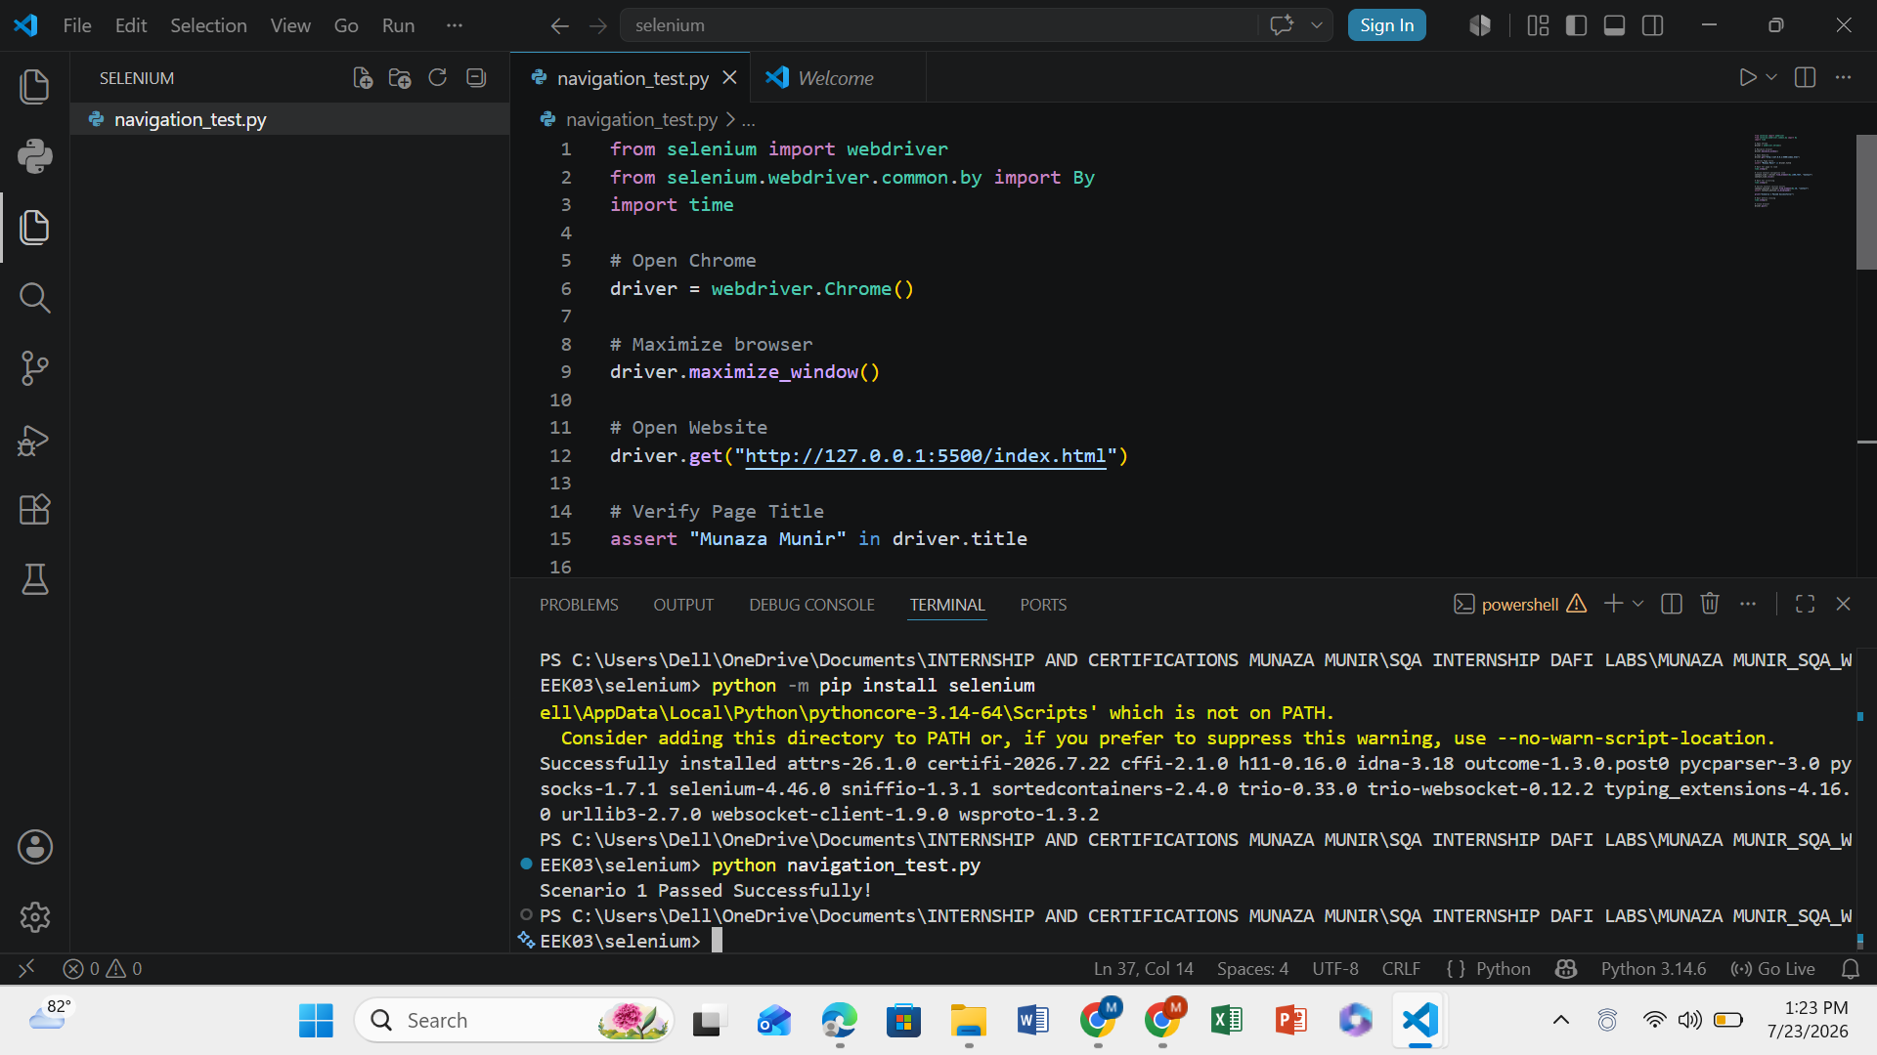

CONTACT FORM TEST USING SELENIUM
PASSED SCENARIO SUCCESSFULLY
